Requirements and Analysis

The Taskmasters

Bradley Snyder, Thomas Walters, Mark Riemer

# Description of System Functionality

The system is a project management system, which will allow a workgroup to collaborate on creating an completing projects. Users will be able to create projects, keep track of tasks assigned them, and monitor overall project status.

# Data Dictionary

**Projects Table**

|  |  |  |  |  |
| --- | --- | --- | --- | --- |
| **Key** | **Field Name** | **Data Type** | **Field Size** | **Comments** |
| P | ID | AutoNumber |  | Unique Random # for reference |
|  | ClientName | Text | 255 |  |
|  | ProjectDescription | Text | Long |  |
| F | ProjectManager | Number |  | Employee ID from Employee Table |
| F | ProjectStatus | Text | 30 | From Status Table |
| F | ProjectType | Text | 30 |  |
|  | DateCreated | Date |  |  |
|  | DateCompleted | Date |  |  |

**Tasks Table**

|  |  |  |  |  |
| --- | --- | --- | --- | --- |
| **Key** | **Field Name** | **Data Type** | **Field Size** | **Comments** |
| P | ID | AutoNumber |  |  |
| F | Project | Number |  | Reference to Project Table |
|  | TaskDescription | Text | Long |  |
| F | RespEmployee | Number |  | Employee ID from Employee Table |
|  | Completed | Bool |  |  |
|  | StartDate | Date |  |  |
|  | EndDate | Date |  |  |
|  | CompletedDate | Date |  |  |
|  | Comments | Text | Long |  |

**Employee Table**

|  |  |  |  |  |
| --- | --- | --- | --- | --- |
| **Key** | **Field Name** | **Data Type** | **Field Size** | **Comments** |
| P | ID | AutoNumber |  |  |
|  | FirstName | Text | 30 |  |
|  | LastName | Text | 30 |  |
|  | ShortName | Text | 5 |  |
|  | Email | Text | 50 |  |

**Status Table**

|  |  |  |  |  |
| --- | --- | --- | --- | --- |
| **Key** | **Field Name** | **Data Type** | **Field Size** | **Comments** |
| P | ID | AutoNumber |  |  |
|  | Description | Text | 20 |  |

# Major use scenarios

Project Creation

1. The user creates a project that the workgroup must complete.
2. The user adds critical information for the project, including:
   1. A description of the project
   2. The client for the project
   3. The project manager with overall responsibility for the project
   4. The project’s type
3. The user enters tasks necessary to complete the project.

Task Creation

1. The user can add a task to a new or existing project.
2. The user identifies the employee responsible for task completion.
3. The user identifies the planned start and end dates for the task.

Task List

1. The user is presented with a list of tasks assigned to the user.
2. The user can mark tasks as completed.
3. The user can extend a task due date.

Add/Edit Employees

1. A user can enter or edit an employee’s identifying information.
2. Once an employee is entered, the employee can be assigned tasks and projects.

Graphical Display

1. A user can view a Gannt chart or similar representation of the project status.

# Description of user interface (prototype)

The website will consist of a project plan screen, a task list screen, and a graphical display of the project schedule. The following are prototypes for each screen.

Project Plan: The primary point of the project plan is to allow a user to easily enter project information and assign tasks.

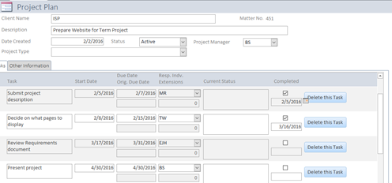

Task List: The task list shows a user what tasks are assigned to them.

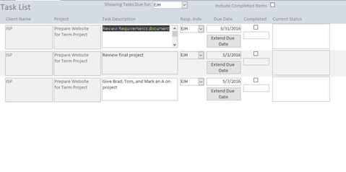

Graphical Display: The website will provide a Gannt Chart or similar view to let a user see a visual representation of progress of a project.

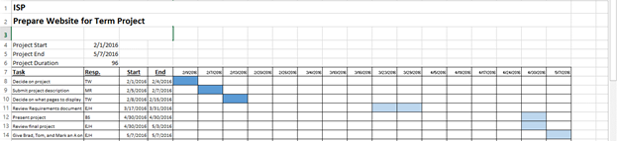

# Team roles for this phase:

Each team member will be principally responsible for one page to ensure each member is exposed to each aspect of the application.

Mark: Set up database tables.

Develop HTML/CSS/JS for Graphical display

Develop queries for Graphical Display page

Thomas: Develop form validation scripts

Develop HTML/CSS/JS for Project Plan.

Develop Queries for Project Plan.

Brad: Write HTML/CSS/JS for Task List

Develop queries for Task List